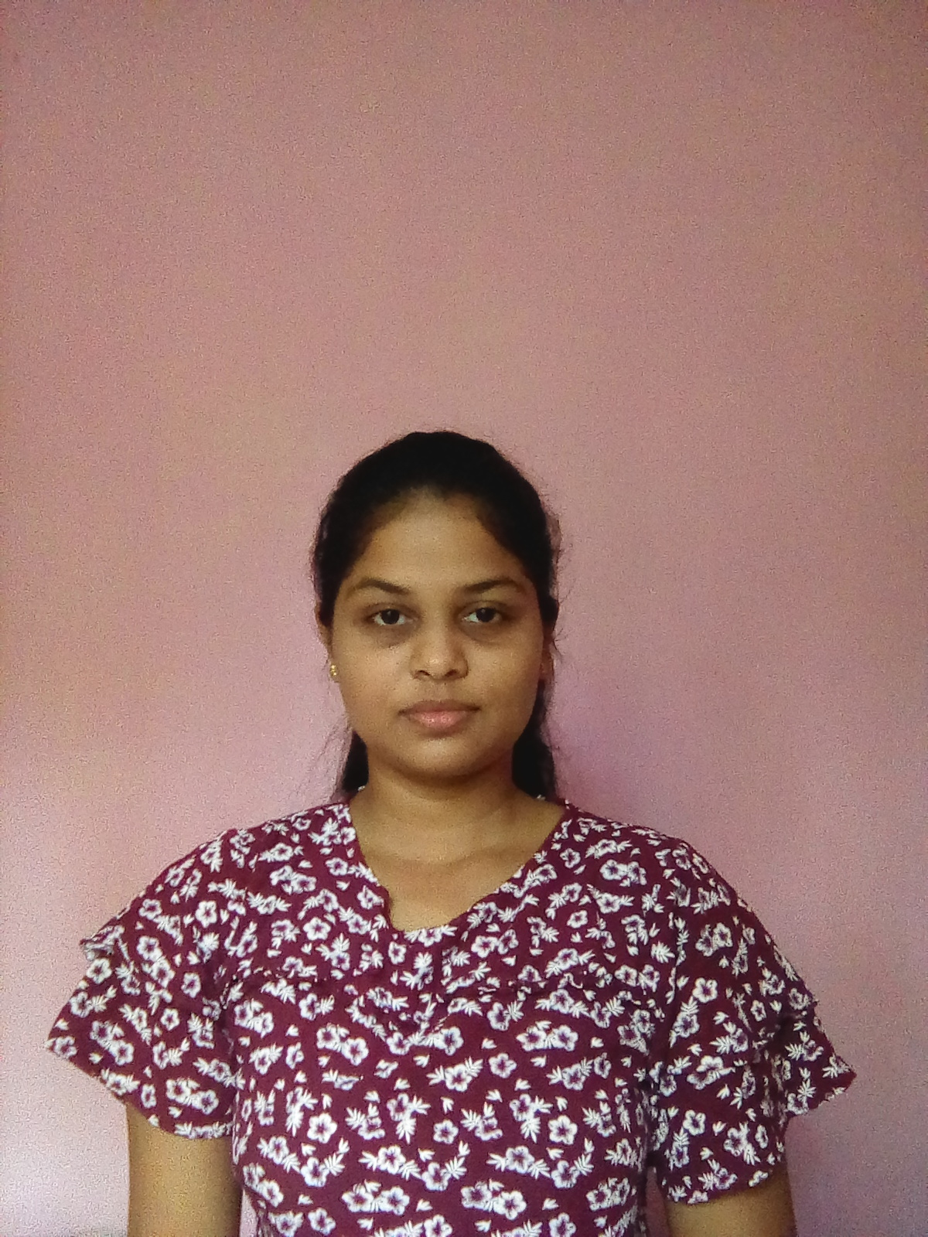

📞 0779113485

**LANGUAGES**

English

Sinhala

🏠 “Amila”, Welikala,

Pokunuwita.

✉ [tdanushika332@gmail.com](mailto:tdanushika332@gmail.com)

Bachelor of Science (Hons) in Biotechnology,

**EDUCATIONAL QUALIFICATIONS**

Secure a responsible career opportunity to fully utilize my training and skill, while making a significant contribution to the success of the company.

CURICULUM VITAE

**THARUSHI DAMINIKA LOKUWITHANA**

**PERSONAL INFO**

**CAREER OBJECTIVE**

Sri Lanka Institute of Information Technology.

I have passed GCE A/L with two C passes and one S pass.

I have passed GCE O/L with six A passes and three B passes.